**Visual Studio Code with Node.JS**

**USING NODE JS**

--github.com/sayar/NodeMVA

https://www.youtube.com/watch?v=R9GYRBDqxI8&list=PLsrZV8shpwjNuvhvotOuzRCQGcqscCekJ

Popular NPM Modules

underscore

async

request

lodash

commander

express

optimist

coffe-script

NPM - Node Package Manager

- Bundled and installed automatically with the environment

Frequent usage

- npm install - save package name

- npm update

How does it working

- Instal dependencies in the local node module folder

- In global mode , make a node module accessable to all

- can install from folder , tarbal and web etc

- can specify dev and optional depedencies

- NPM can also install the depedencies for a project by reading the package.json

Async Modules - utility module which provides straight forward , powerfull function for working with asynchronouse javascript

async.map

async.filter

async.parallel

async.series

Request Modules - Designated to be the simplest way possible to make http calls.

It supports HTTPS, streaming and follows redirect by default

Using Node.js with VS Code: 02 Introduction to Express

--github.com/sayar/NodeMVA

https://www.youtube.com/watch?v=GGrtjNbpEDo&index=2&list=PLsrZV8shpwjNuvhvotOuzRCQGcqscCekJ

What is Express

Installing and using express

DEMO : Creating a simple REST API

Templating

What is Express?

<https://www.youtube.com/watch?v=GGrtjNbpEDo&list=PLsrZV8shpwjNuvhvotOuzRCQGcqscCekJ&index=2>

- express is a minimal, open source and flexible node.js web.app frameworks designed to make developing websites, web apss and API's much easier

- Support multiple templating engines to simplify generating HTML

Installing Express

- npm install express

- npm install jade

02 - Creating a Simple REST API

Explanation of Routes

- A router maps HTTP request to a callback

- HTTP request can be sent as GET/POST/PUT/DELETE etc

- URLs describe the location of targeted

- Nodes helps you map a HTTP GET request likeL:

- http://localhost:8888/index

- To a request handler (callback)

app.get('/index', function(req,res){});

DEMO

**Using Express for Multiple Pages**

D:\Litopascua\GitHub\NodeJSLearn1\NodeJSLearn1\11_ExpressMultipleRoutes\routes

Go to NodeJSLearn1 main directory

Npm install express-generator –g

Express

Do

Npm intall

Npm start

Goto the

Localhost:3000

<https://www.youtube.com/watch?v=GGrtjNbpEDo&list=PLsrZV8shpwjNuvhvotOuzRCQGcqscCekJ&index=2>

BUILDING RESTful API for Dogs

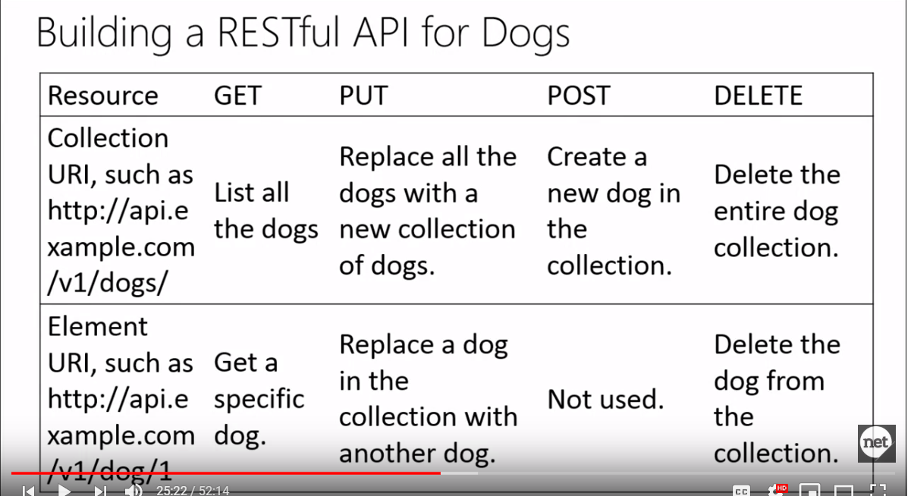

Express to Build a RESTful API

Resources

* Express Framework <http://expressjs.com>
* Intro to express
* Jade template <http://jade-lang.com/tutorials>
* Javascript and Jade templating

<http://www.slideshare.net/wearefractal/jade-javascript-templating>

* GitHub

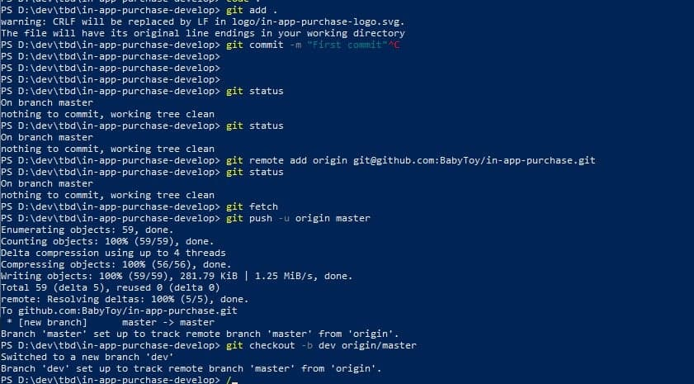

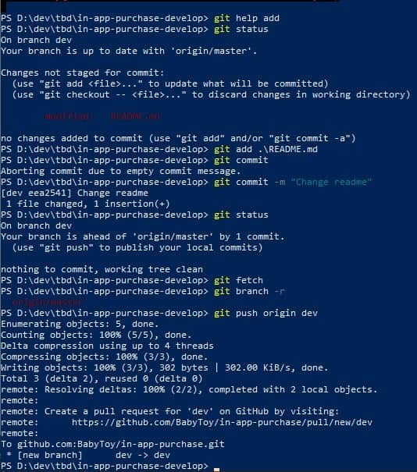

Express to Build a RESTful API

Resources

<https://www.youtube.com/watch?v=GGrtjNbpEDo&list=PLsrZV8shpwjNuvhvotOuzRCQGcqscCekJ&index=2>

* Express Framework <http://expressjs.com>
* Intro to express
* Jade template <http://jade-lang.com/tutorials>
* Javascript and Jade templating

<http://www.slideshare.net/wearefractal/jade-javascript-templating>

use postman for Chrome